LAB 4: OPERATIONAL AMPLIFIER CIRCUITS

Introduction
Operational amplifiers (OAs) are highly stable, high gain, difference amplifiers that can handle signals from zero frequency (dc signals) up to the MHz range. They are used for performing mathematical operations on their input signal(s) in real-time and are an important component of analog computation networks. A large variety of OAs is commercially available in the form of low cost integrated circuits. In these experiments, a commercially available device (like the LM324 or the LM741) OA will be used.
Figure 1 shows the symbol for an OA. There are two inputs, the inverting input (-) and the non-inverting input (+). These symbols have nothing to do with the polarity of the applied input signals.
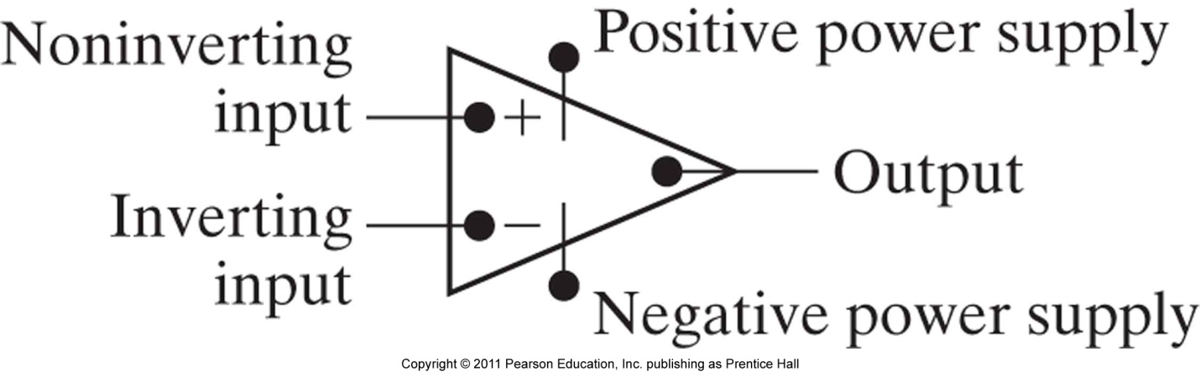
Figure 1 Circuit symbol for the operational amplifier (taken from [1]).

The output signal voltage, v_{o}, is given by:
v_{o} = A(v₊ - v₋)
where v₊ and v₋ are the signals applied to the non-inverting and to the inverting input, respectively and Α represents the open loop gain of the OA. The gain A is infinite for the ideal operational amplifier, whereas for the various types of real OAs, it is usually within the range of 10⁶ to 10⁸. The input resistance of both OA inputs is extremely high (usually within the range 10⁸ - 10¹² MΩ). For an ideal OA the input resistance is infinite, thus no current flows into the two OA inputs.
Operational amplifiers, of the type used here, require a bipolar power supply to operate, i.e., a positive voltage (+V) and a negative voltage (-V) with respect to ground. The bipolar power supply allows OAs to generate an output voltage signal, v_{o}, of either polarity. The output signal range is not unlimited. The voltages of the power supplies determine its actual range. Thus, a typical OA supplied with -15 and +15 V, may yield a v_{o} approximately within the -13 to +13 V range. This is called the operational range. Any result expected to be outside this range is clipped to the respective limit, and the OA is in a saturation stage.
Because of their very high open loop gain, OAs are almost exclusively used with some additional circuitry (mostly with resistors and capacitors), required to ensure a negative feedback loop. The feedback loop stabilizes the output within the operational range and provides a much smaller but precisely controlled gain, called the closed loop gain. For an ideal OA with feedback, the voltages at the two inputs, v₊ and v₋, are equal.
There are many circuits with OAs performing various mathematical operations. Each circuit is characterized by its own input-output relationship which is the mathematical equation describing the output signal, v_{o}, as a function of the input signal(s). v₁, v₂, …, v_{n}. Generally, these relations can be derived by applying Kirchhoff’s Laws and assuming an ideal OA.

Inverting amplifier

The circuit for an inverting amplifier is shown in Figure 2.

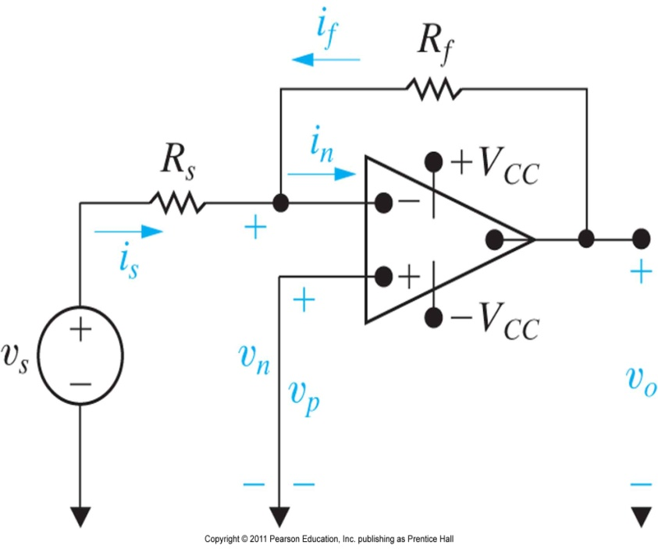
Figure 2 Inverting amplifier circuit (taken from [1]).

- Derive the input-output relation: v_{o} = f(v_{s},R_{s},R_{f}).
- For V_{CC} = 15 V, use v_{s} = 1 V, R_{s} = 1 kΩ and R_{f} = 10 kΩ. Measure v_{o} and verify that the input-output relation is satisfied.
- Continue to use V_{CC} = 15 V, v_{s} = 1 V and R_{s} = 1 kΩ. Choose values for R_{f} from 11 kΩ to 20 kΩ (in steps of 1 k Ω) and measure v_{o}. Discuss when the input-output relation is satisfied and when clipping occurs. Why does clipping occur for some values of R_{f} ?

Noninverting amplifier

The circuit for a noninverting amplifier is shown in Figure 3.

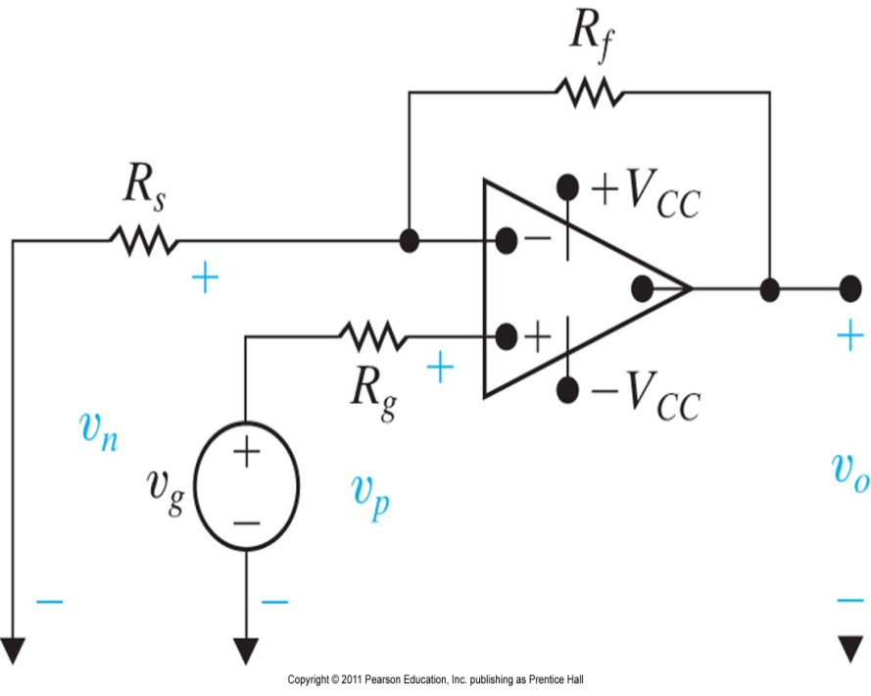

Figure 3 Noninverting amplifier circuit (taken from [1]).

- Derive the input-output relation: v_{o} = f(v_{g},R_{s},R_{f},R_{g}).
- Use V_{CC} = 15 V, v_{g} = 1 V and R_{g} = 1 kΩ. Design a noninverting amplifier (choose values of R_{s} and R_{f}) with an output voltage of v_{o} = 3 V such that the power dissipated in R_{s} and R_{f} is less than or equal to 0.003 W. Measure v_{o} and verify that the input-output relation is satisfied. Show all your calculations.

Ideal Differentiator

The differentiator generates an output signal proportional to the first derivative of the input with respect to time. The circuit is shown in Figure 4.
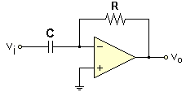

Figure 4 Differentiator circuit

The input-output relation of this circuit is
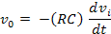
Derive the input-output relation given above and explain why any input noise is amplified at high frequencies.
Ideal Integrator

The integrator generates an output signal proportional to the time integral of the input signal. The circuit is shown in Figure 5.
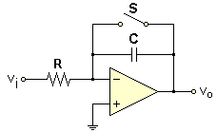

Figure 5 Integrator circuit
The input-output relation of this circuit is
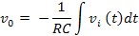

The output remains zero when the switch S remains closed. The integration starts (t = 0) when S opens.

Derive the input-output relation given above, and explain why input signals with low frequencies are amplified.

Practical Differentiator

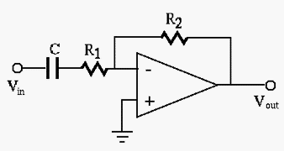
Figure 6 Practical Differentiator circuit

To mitigate the problem of noise amplification at high frequencies, a differentiator used in practice is given in Figure 6. Differentiation of the input signal is accomplished over a bandwidth of low frequencies.

- Derive the input-output relation for the circuit of Figure 6. This can be done in the Laplace transform domain. [We will do this later in ELEC 225/226.]
- For R₁ = 1.6 kΩ, R₂ = 100 kΩ and C = 0.01 µF, run the following MATLAB program to plot the magnitude response of the circuit.
R1 = 1.6e3; R2 = 100e3; C = 0.01e-6;
n= [-R2*C 0]; d = [R1*C 1];
[h, w] = freqs(n, d);
ah = abs(h);
f = w/(2*pi);
plot(f,ah); xlabel('Frequency (Hz) '); ylabel('Gain ');
- Explain the MATLAB code. Submit all plots.
- From the plot, deduce the bandwidth of frequencies for which differentiation is performed. (Where is the slope linear?)
- For high frequencies, the circuit reduces to an inverting amplifier with absolute gain R₂/R₁. After about what frequency does this occur (deduce from the plot)?
- Using the component values given above, build the circuit. Observe and explain the input and output waveforms on the oscilloscope. Use the following inputs:
- A square wave (500 Hz fundamental) with a peak to peak voltage of
100 mV.
- A triangular wave (500 Hz fundamental) with a peak to peak voltage of 100 mV.
- A 500 Hz sine wave with a peak to peak voltage of 100 mV. Increase the frequency of the sine wave to 1000 Hz, 1500 Hz, 2000 Hz, 3000 Hz, 5000 Hz, 10000 Hz, 20000 Hz, 30000 Hz and 40000 Hz.
Explain what you observe.

Lab Report Format

- Title Page
- Table of Contents
- Abstract
- Introduction and Objectives of Laboratory Experiment
- Background Material on Operational Amplifiers
- Results and Discussion. Include the answers to the questions given above.
- Conclusions
- References
- Appendices

The lab reports may be handwritten (or a combination of typed and handwritten), with one report per lab group. Please refer to the lab report rubric document on the ELEC 225 labs page for guidance on how the lab reports will be evaluated.

References

- J. W. Nilsson and S. A. Riedel, Electric Circuits, 9th edition, Prentice-Hall, 2011.

